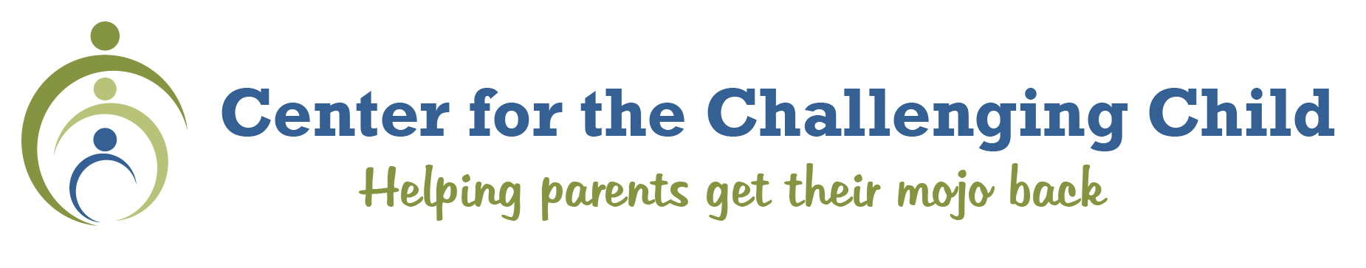
Join Parenting Coach Certification students for a Weekend Intensive Training that’s open to educators, social workers, clergy, parent coaches, medical professionals,
and all who coach parents on behavior.

Dates: March 12-14, 2020 from 1 p.m. on Friday until 12:30 on Sunday.
Location: TBD
For non-class members, the $399 fee includes 15 CEUs for the weekend learning hours.
To register for the weekend only, visit www.parentingmojo.com/become-parent-coach
or email tina@parentingmojo.com. All 10-month class members have been paid up with their class fee.

Schedule:
Day I: March 12, 2020
1:00p-1:30p Introductions, welcome, orientation Tina Feigal
1:30p-3p Grief, Loss and Trauma Anu FS Social Worker
3:15p-3:30p Break
3:30p-4:15p Grief, Loss, and Trauma Anu FS Social Worker
4:15p-4:30p Wrap-up, Questions, Planning Tina Feigal
6:30p-8:30p Axel’s Networking Event (heavy hors d’oeuvres) All

Day II: March 13, 2020
8:30a-9:00a Welcome, De-brief, Questions
9:00a-10:00a Trauma Effective Team Meetings Tina Feigal
10:00a-10:15a Break
10:00a-11:00a Coaching Session I (Introduction Session) Tina Feigal
11:00a-12:00 De-Brief Session I with Coach and Parents
12noon-1:00p Lunch
1:00-2:00p Coaching Session II Tina Feigal
2:00p-2:45p De-Brief Session II with Coach and Parents
2:45p-3:00p Break
3:00p-4:00p Coaching Session III Tina Feigal
4:00-4:45p De-Brief Session III with Coach and Parents
4:45p-5:00p Wrap-up, Questions, Planning

Day III: March 14, 2020
8:30a-9:00a Welcome, De-brief, Questions Tina Feigal
9:00a-10:30a Breakout/Role Plays/Scenarios Tina Feigal
10:30a-10:45a Break
10:45-11:45 Group Debriefing on Practice Coaching Tina Feigal
11:45-12:30 Importance of Coaching/Wrap-up, Next Steps Tina Feigal

We’d love to have non-enrolled professionals join us!
The fee is $399 if not already enrolled in the PCC class. Visa and Mastercard are accepted.
Checks are payable to:
Anu Family Services, Inc., 901 Fourth St., Suite 180 Hudson, WI 54016.

